Seven Steps in Judging a Horoscope
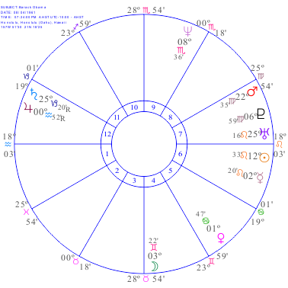Aspect Grid
Name: Barack Obama
Date: August 4, 1961
Time: 7:24 PM
Place: Honolulu, Hawaii
Rodden Rating: AA
 | À | Á | Â | Ã | Ä | Å | Æ | Ç | È | É | Ê | Ë | Planet | Adynes | Harm
À |  | aspect | aspect | aspect | aspect | aspect | aspect | aspect | aspect | aspect | aspect | aspect | À
Á |  |  | aspect | aspect | aspect | aspect | aspect | aspect | aspect | aspect | aspect | aspect | Á
Â |  |  |  | aspect | aspect | aspect | aspect | aspect | aspect | aspect | aspect | aspect | Â
Ã |  |  |  |  | aspect | aspect | aspect | aspect | aspect | aspect | aspect | aspect | Ã
Ä |  |  |  |  |  | aspect | aspect | aspect | aspect | aspect | aspect | aspect | Ä
Å |  |  |  |  |  |  | aspect | aspect | aspect | aspect | aspect | aspect | Å
Æ |  |  |  |  |  |  |  | aspect | aspect | aspect | aspect | aspect | Æ
Ç |  |  |  |  |  |  |  |  | aspect | aspect | aspect | aspect | Ç
È |  |  |  |  |  |  |  |  |  | aspect | aspect | aspect | È
É |  |  |  |  |  |  |  |  |  |  | aspect | aspect | É
Ê |  |  |  |  |  |  |  |  |  |  |  | aspect | Ê
Ë |  |  |  |  |  |  |  |  |  |  |  |  | Ë

Planetary Distribution Grid:
Quadruplicities |  |  | Triplicities |  |  |  | Power
MOV | FIX | MUT | FIRE | EARTH | AIR | WATER | ANG | SUC | CAD
Societies |  |  | Trinities |  |  |  |  |  | Expression
PER | COMP | PUB | LIFE | WEATLTH | ASSOC | PSY | ABOVE | EAST | D of E*
*Degree of Emanation (count degree of emanation for ÀÁÂË)
- Power: Choose an item.
- Adaptability – degree of versatility & success in accommodating change
  - Quadruplicity: Choose an item.
  - Planets East/West: Choose an item.
- Temperament – characteristic or habitual attitude, mood and behavioral responses
  - Triplicity: Choose an item.
  - Degree of Emanation: Choose an item.
- Important Departments of Life – Life Emphasis
  - Societies: Choose an item.
  - Trinities: Choose an item.
- Houses with Planets and
- Houses without Planets
House | Department of Life | Chief Ruler and Corresponding Influence | House having authority over this house
1 | Personality, personal matters, physical body | Choose an item. | Choose an item.
2 | Money and possessions | Choose an item. | Choose an item.
3 | Thoughts, writing, siblings, neighbors | Choose an item. | Choose an item.
4 | Home, private life, secret things, end of life, real estate, father | Choose an item. | Choose an item.
5 | Love, entertainment, children, gambling | Choose an item. | Choose an item.
6 | Work, workmates, illness, subordinates, servants | Choose an item. | Choose an item.
7 | Marriage, partnership and open enemies | Choose an item. | Choose an item.
8 | Partner’s money, death and inheritance, inner plane friends | Choose an item. | Choose an item.
9 | Religion, philosophy, higher learning, long journeys | Choose an item. | Choose an item.
10 | Honor, credit and reputation, job, mother, superiors | Choose an item. | Choose an item.
11 | Friends, hopes and wishes | Choose an item. | Choose an item.
12 | Restrictions, disappointments, secret enemies | Choose an item. | Choose an item.

- Preliminaries
  - Note the Prominent Planets & Powerful Conjunctions. Definition of Prominence: Planet is
    - In an Angle or
    - Makes powerful aspects to Sun or Moon or
    - Is high on the list of Astrodyne Power.
  - Determine Dominant Planet
    - Usually in an angle and making powerful aspects
    - Top of astrodyne power list (Not including MC and Asc!)

